Name: Sapargali Temirlan
Group: SE-2403
Instructor: Kozhakhmet Zhaksylyk
PART 2 TASK 3
Deriverables
Unoptimized and optimized contracts are in their respective files.
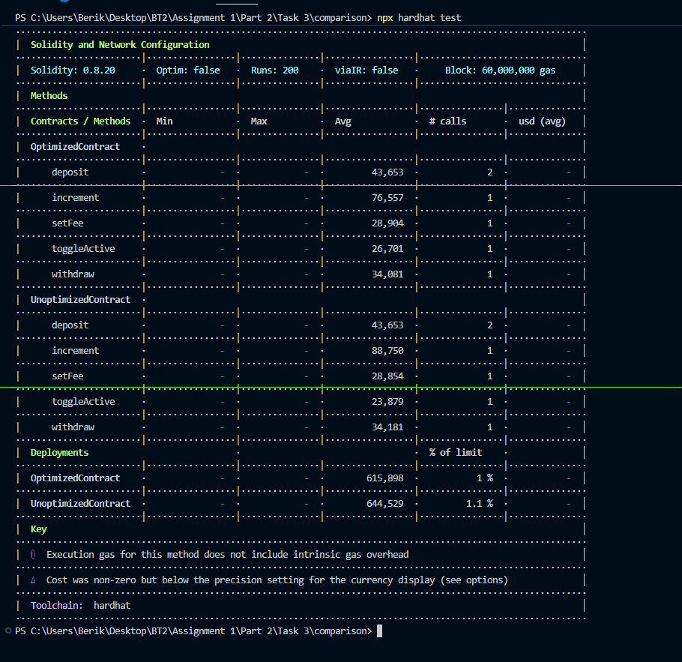

 | Optimization | Gas Impact | Explanation
1 | Custom Errors | High | Saves ~200–300 gas vs revert strings
2 | Immutable Owner | High | Removes SLOAD when reading owner
3 | Constant | Medium | Stored in bytecode, no storage slot
4 | Storage Packing | High | Packs fee + count + bool into 1 slot
5 | Event Logging | High | Avoids repeated SSTORE in loops
6 | Caching Storage Reads | Medium | Avoids multiple SLOAD operations
7 | Calldata | Medium | Avoids memory copy for arrays
8 | Unchecked Arithmetic | Medium | Removes overflow checks in loops
9 | Short-circuiting | Low | Fails early, cheaper execution path

